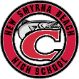
NSBHS Class of 2023
“Walking in White” Requirements & Deadlines

New Smyrna Beach High School has a long-standing tradition of recognizing Honor Students for excellence in academic achievement by “Walking in White” at each Graduation Ceremony.

Applications for “Walking in White” will be available for pick up at the School Counseling Office front desk beginning Monday, January 30, 2023.

Students requesting to “Walk in White” must meet all below requirements by the 2022-2023 Deadline: Friday April 14, 2023.

“Walking in White” Requirements
Students must meet ALL requirements listed below & turn in the completed “Walking in White” application to Mrs. Ursini at the Counseling Office front desk by Friday April 14, 2023.
“Walking in White” Requirement | Explanation
3.5 Weighted GPA | - Student GPAs will calculate at the conclusion of Semester 1. At that time, your GPA must meet the 3.5 Weighted GPA requirement.  - GPAs calculate at the conclusion of each semester. Students will not be permitted to wait until the conclusion of Semester 2 to meet the GPA requirement.
10 Honors Courses  (Courses can be a combination of any listed below)  Honors  Advanced Placement  AICE  Dual Enrollment | - Students must meet this requirement for eligibility
Test Scores  ACT(Composite) - 23  SAT(Critical Reading & Math) – 1100  Students who are eligible for Free & Reduced Lunch qualify for two free testing fee waivers for both assessments (2 ACT fee waivers & 2 SAT fee waivers)  Families may apply for Free & Reduced Lunch via the website below –  https://www.vcsedu.org/schoolwaycafe/free-and-reduced-meal-applications | - Students may meet the testing requirement with either qualifying score (ACT or SAT)  - Students must plan to take the ACT/SAT assessments early enough to receive the qualifying score  - Students will not be permitted to submit qualifying ACT/SAT Test scores after the April 14, 2023 Deadline  - Final ACT Assessment date to meet the deadline – February 11, 2023  - Final SAT Assessment date to meet the deadline – March 11, 2023
75 Pre – Approved Community Service Hours | - Before tracking volunteer hours, students must complete the online training & Youth Partnership Program Agreement.  - Detailed information can be located at www.nsbhigh.com, Counseling, Community Service Information
The deadline to complete all requirements & submit the completed “Walking in White” application is Friday April 14, 2023. NO applications will be considered after the deadline, Friday April 14, 2023.
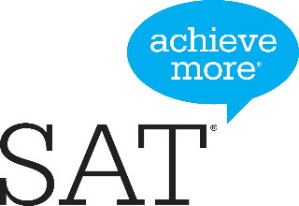
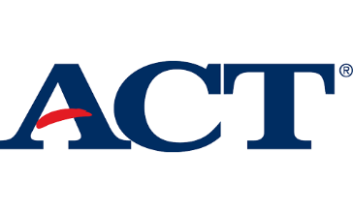
2022 - 2023
ACT & SAT DATES
SCHOOL CEEB CODE: 101230
ACT  www.actstudent.org |  |  | SAT  www.sat.org/register
Test Date | Deadline | Late Deadline | Test Date | Deadline | Late Deadline
September 10, 2022 | August 5, 2022 | August 19, 2022 | August 27, 2022 | July 29,2022 | August 16, 2022
October 22, 2022 | September 16, 2022 | September 30, 2022 | October 1, 2022 | September 2, 2022 | September 20, 2022
December 10, 2022 | November 4, 2022 | November 11, 2022 | November 5, 2022 | October 7, 2022 | October 25, 2022
February 11, 2023 | January 6, 2023 | January 20, 2023 | December 3, 2022 | November 3, 2022 | November 22, 2022
April 15, 2023 | March 10,2023 | March 24, 2023 | March 11, 2023 | February 10, 2023 | February 28, 2023
June 10, 2023 | May 5, 2023 | May 19, 2023 | May 6, 2023 | April 7, 2023 | April 25, 2023
July 15, 2023  *Available at other test sites | June 16, 2023 | June 23, 2023 | June 3, 2023 | May 4, 2023 | May 23, 2023

Students eligible for free or reduced lunch can receive two fee waivers for each the ACT and SAT. Additionally, students who use a SAT fee waiver can receive admissions fee waivers to apply to up to 4 participating colleges/universities. Please see your school counselor for more information.
* July 15, 2023 test not given at NSBHS ACT/SAT Test Prep available at http://volusialibrary.org/

