Dear Parent or Guardian,

On January 20, February 9, February 16, March 20, and April 6, 2023 we at New Smyrna Beach High School will begin to show videos addressing Safety, Decision Making, Substance Abuse Prevention and Mental Health to meet the state mandate for required instruction in these areas.

The program used for this lesson is the MBF Teen Safety Matters, which teaches teens about emotional, physical, and digital safety. It is based on the latest research and has been reviewed and endorsed by national experts. Within the lesson, they will learn about the MBF Teen Safety Matters Safety Rules:

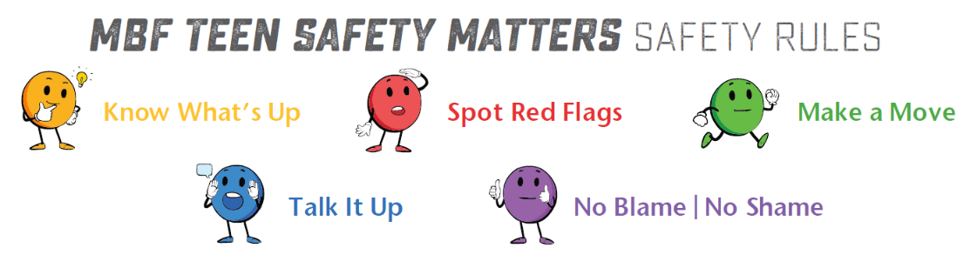

Objectives for the 2 safety lessons include the following:

Lesson 1 | Lesson 2
- Digital self-awareness and self-management  - Define, identify, and know how to talk to a safe adult  - Define, identify, and know how to talk to a safe friend  - CATCH of Technology: Choices, Attachments & Relationships, Time, Character & Reputation, Health & Safety  - Learn that online postings are “Public and Permanent”  - Cyberbullying  - Online personal safety | - Define abuse and how to identify red flags  - Define and identify terms and types of Human Trafficking (force, fraud, coercion, labor trafficking, domestic servitude)  - Understand bystanders vs upstanders  - Bullying  - Healthy vs Unhealthy relationships

If you DO NOT want your child to participate in the program lessons, please complete the following form and return the form to the school. Please do not hesitate to contact the school with any concerns before opting your child out of the program.

RESOURCES TO LEARN MORE:

- www.IROC2.org www.pacer.org/bullying/resources/parents/
- www.kidshealth.org/en/teens/internet-safety.html www.kidshealth.org/en/parents/child-abuse.html
- www.nteens.org www.polarisproject.org/human-trafficking
- www.mbfpreventioneducation.org www.loveisrespect.org
Dear Parent/Guardian:

Florida legislation (6A-1.094124) requires all students, grades 6th -12th, to receive instruction in mental health, child trafficking prevention, and substance abuse. In Volusia County schools, students will plan to receive this instruction through a developmentally appropriate lesson within their class day. Parent Information Sheets will follow the videos providing additional follow up that you may want to discuss or review with your students at home in the form of a Connect Ed message. Lesson topics will include the following:

Introduction to Mental Health, Physical Health & Wellbeing | General understanding to help reduce stigma
Coping Skills | Ways to manage and reduce stress and challenges
Signs of Mental Illness | Understand how to recognize the signs and how to seek help for themselves and their friends, if needed
Seeking Help | Who to reach out to for help, in terms of a trusted adult or helping professional, and about local and national resources that can be accessed when help is needed
Safety & Substance Abuse | How to recognize and respond to bullying/cyberbullying, abuse, digital dangers, and substance abuse. It teaches that adults are responsible for their safety but there are things they can do to help adults keep them safe

Programs used for this year are a combination of the Monique Burr Foundation’s Teen Safety Matters® Program and Lauren’s Kids Safer, Smarter Teens curriculum, both have which been reviewed and endorsed by national experts and implemented in districts throughout the State of Florida.
You can learn more about these programs at www.mbfpreventioneducation.org and www.LaurensKids.org and www.SaferSmarterSchools.org .

When teens are taught safety information, rules to keep them safe, and better understand their own wellness, they perform better in school and enjoy healthier, happier, and safer lives.

IF YOU “DO NOT” WANT YOUR TEEN TO PARTICIPATE IN THE PROGRAM LESSONS, COMPLETE THE FOLLOWING FORM & RETURN THE FORM TO THEIR SCHOOL.

The lessons provide students with important information about mental wellness, communicating concerns, and potential dangers they may face. If you do not want your teen to participate, please have these discussions with them or use another program. Please contact the school with any concerns before opting your teen out of the program.

The lessons will be delivered in the classroom by your child’s teacher. Mental Health Counselors and School Counselors will be made available for any students who may be triggered or need to debrief about any of the material. Lessons will rotate classes so as not to impede on the instructional time of one particular subject. Dates and class period include the following:

Period 2 | Safety Lesson 1– (1/19)
Period 3 | Safety Lesson 2– (2/9)
Period 4 | Mental Health Lesson 1– (2/16)
Period 5 | Mental Health Lesson 2– (3/20)
Period 6 | Mental Health Lesson 3– (4/6)

IF YOU “DO NOT” WANT YOUR TEEN TO PARTICIPATE IN THE PROGRAM LESSONS, COMPLETE THE FOLLOWING FORM & RETURN THE FORM TO THEIR SCHOOL.

I understand returning this form means I DO NOT WANT MY TEEN TO PARTICIPATE in the district instruction on Mental and Emotional Health Education, Substance Use and Abuse Health Education, and Child Trafficking/Safety Prevention Education.

I UNDERSTAND THEY WILL NOT RECEIVE THE IMPORTANT INFORMATION contained in the program.

Student’s Name: __________________________________________________ Grade: ______________
Parent/Guardian Printed Name: ________________________________________________________________
Parent/Guardian Signature: _________________________________________ Date: _______________
Parent/Guardian Email: _____________________________________________
Parent/Guardian Phone Number: _____________________________________

